helm create repo

The helm repo index command will generate an index file

based on a given local directory that contains packaged charts

add, list, remove, update, and index chart repositorie

This command consists of multiple subcommands to interact with chart repositories.

It can be used to add, remove, list, and index chart repositories.

helm wait: Helm will wait until a minimum expected number of Pods in the deployment are launched before marking the release as successful

helm atomic: if set, upgrade process rolls back changes made in case of failed upgrade. The --wait flag will be set automatically if --atomic is used

force : force resource updates through a replacement strategy

(role-role, rolebased-rb, cluster role-c.role and cluster role binding crb)

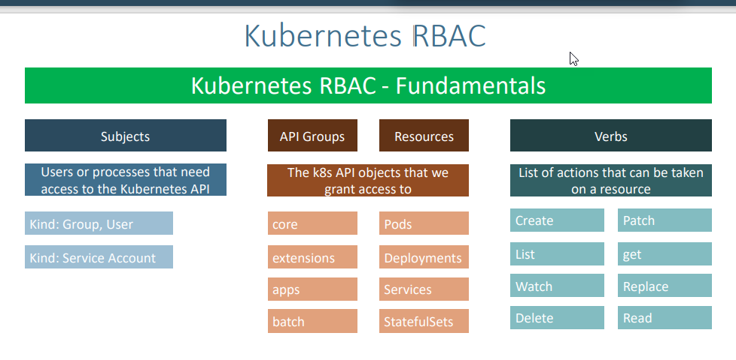

Subjects: if user want to access the k8s API

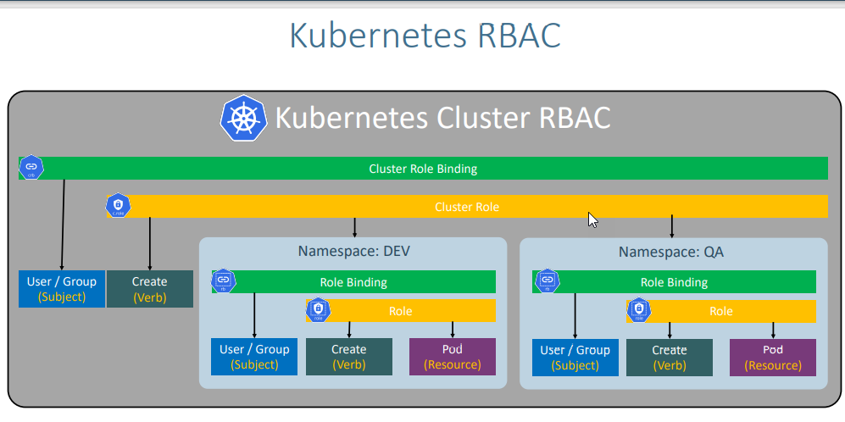

* role and role binding is at name space level
* cluster role and cluster role binding is k8s cluster level resources rbac level

A role can be used to grant the access to resources within a single namespace

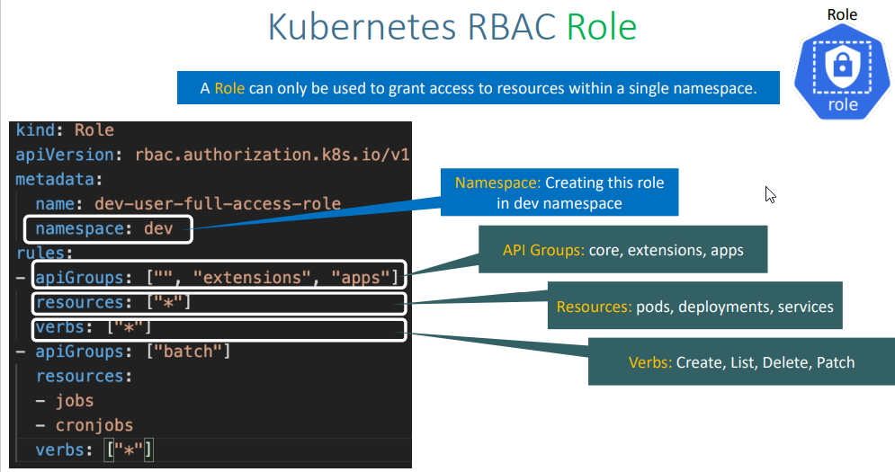

* For namespace dev it is going to give full access role

(namespace: dev) means it creates the role binding in dev namepsace

(rules: Api groups: core, extension,apps

resources: pods, deployment and services

verbs: create, list delete path)

Role Binding

* role binding is used to tie the role and subject (user, group, service account who needs to access the respective resource in k8s cluster) together
* role (namespace and subject (azure ad) object id is referenced in role binding)

role ref: we will specify the role which needs to be binded with respective subject (name of the role which we are referring)

group id: azure ad group with object Id

